**8 week sql challenge**

Each of the following case study questions can be answered using a single SQL statement:

1) What is the total amount each customer spent at the restaurant?  
Ans :  
 select distinct(s.customer_id) ,sum(m.price) as amt

from dbo.sales s

JOIN dbo.menu m

ON s.product_id = m.product_id

group by s.customer_id;

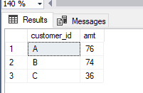

2) How many days has each customer visited the restaurant?  
Ans :

select COUNT(order_date) as days, customer_id from dbo.sales GROUP BY customer_id;

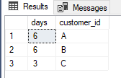

3)What was the first item from the menu purchased by each customer?  
Ans :  
with Rank as

(

select

s.customer_id,

m.product_name,

s.order_date,

DENSE_RANK() over (partition by s.customer_id order by s.order_date) as rank

from menu m

join sales s

On m.product_id = s.product_id

group by s.order_date,m.product_name, s.customer_id

)

select Customer_id, product_name

from Rank

where rank = 1

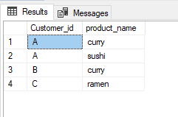

4)What is the most purchased item on the menu and how many times was it purchased by all customers?  
Ans :  
  
select s.product_id, count(s.product_id) mostTimePurchased, m.product_name

from sales s

join menu m

ON s.product_id = m.product_id

group by s.product_id, m.product_name

having count(s.product_id) > 1  
  
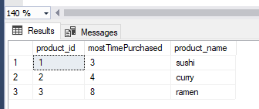

5)Which item was the most popular for each customer?  
with rank as (

select s.customer_id,

m.product_name,

count(s.product_id) as Count,

DENSE_RANK() Over (partition by s.customer_id order by count(s.product_id) DESC) as Rank

from menu m

join sales s

On m.product_id = s.product_id

group by s.customer_id,m.product_name,s.product_id)

select customer_id, product_name, Count

from rank

where rank =1  
  
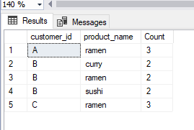

6)Which item was purchased first by the customer after they became a member?  
Ans :   
with Rank as

(

select

s.customer_id,

mem.join_date,

m.product_name,

s.order_date,

DENSE_RANK() over (partition by s.customer_id order by s.order_date) as rank

from menu m

join sales s

On m.product_id = s.product_id

join members mem

On s.customer_id = mem.customer_id

where s.order_date >=mem.join_date

)

select *

from Rank

where rank = 1

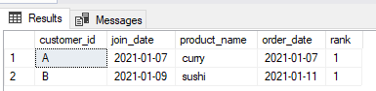

7)Which item was purchased just before the customer became a member?  
with Rank as

(

select

s.customer_id,

mem.join_date,

m.product_name,

s.order_date,

DENSE_RANK() over (partition by s.customer_id order by s.order_date) as rank

from menu m

join sales s

On m.product_id = s.product_id

join members mem

On s.customer_id = mem.customer_id

where s.order_date < mem.join_date

)

select *

from Rank

where rank =1

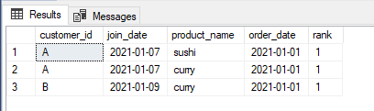

8)What is the total items and amount spent for each member before they became a member?

Ans :

Solution 1)  
select distinct(s.customer_id) ,sum(m.price) as amt

from dbo.sales s

JOIN dbo.menu m

ON s.product_id = m.product_id

join dbo.members mem

on s.customer_id = mem.customer_id

where s.order_date < mem.join_date

group by s.customer_id;  
  
Solution 2)  
with Rank as

(

select

s.customer_id,

mem.join_date,

m.product_name,

m.price,

s.order_date,

DENSE_RANK() over (partition by s.customer_id order by s.order_date) as rank

from menu m

join sales s

On m.product_id = s.product_id

join members mem

On s.customer_id = mem.customer_id

where s.order_date <mem.join_date

)

select distinct(customer_id) , sum(price) as amt

from rank

group by customer_id

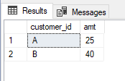

9)If each $1 spent equates to 10 points and sushi has a 2x points multiplier - how many points would each customer have?

Ans :   
Solution 1)

with TempTable as (

select *,

Case when product_id IN (2,3) then (price * 10) else (price * 20) End as point

from menu

)

select s.customer_id, sum(point) as points from TempTable t

join sales s

on s.product_id = t.product_id

group by s.customer_id;

Solution 2)

with TempTable as (

select *,

Case when product_name = 'sushi' then (price * 20) else (price * 10) End as point

from menu

)

select s.customer_id, sum(point) as points from TempTable t

join sales s

on s.product_id = t.product_id

group by s.customer_id;

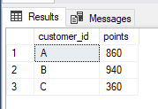

10)In the first week after a customer joins the program (including their join date) they earn 2x points on all items, not just sushi - how many points do customer A and B have at the end of January?  
with TempTable as (

select *,

Case when product_id in (1,2,3) then (price * 20) End as point

from menu

)

select s.customer_id, sum(point) as points from TempTable t

join sales s

on s.product_id = t.product_id

join members mem

on s.customer_id = mem.customer_id

where s.order_date < = dateadd(day,7, mem.join_date)

group by s.customer_id;